How to Change Your Vehicle’s Brakes

CHARLOTTE -- Changing your brakes is a task you CAN tackle. Your car features an intricate braking system with a whole range of components that work in tandem to ensure that you stop safely and on time when you hit the brakes. If you have the right know-how and the right tools, however, it’s possible to change your brakes right in your own garage.

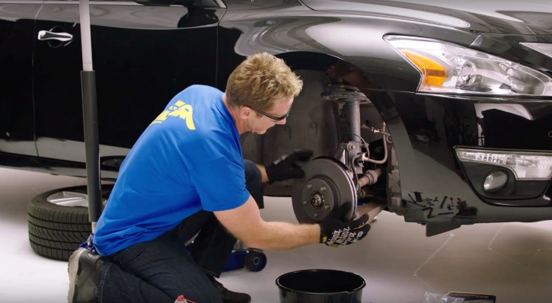
The automotive experts at Goodyear Brakes, which are developed and sold by FDP Virginia Inc., offer some tips for assessing the health of your vehicle’s braking system, as well as advanced solutions for addressing any issues.

What Do You Need to Change Your Brakes?
Here’s a quick list of what you’ll need to have on hand before changing your car’s brakes:
- Safety glasses
- Floor jack (car jack)
- Jack stands
- Mechanics gloves plus nitrile gloves
- Wheel chocks or plywood
- Flathead screwdriver
- Breaker bar
- Socket set/ratchet-metric or SAE (inch)
- Wrench set-metric or SAE (inch)
- Allen or Torx bit (for certain vehicles)
- Heavy hammer
- Brake caliper compression tool or C-clamp
- 3/8” or 1/2” torque wrench
- Wire brush
- Bungee cord or zip ties
- Threadlocker
- Parts cleaner or brake cleaner

The new line of Goodyear Brakes provides premium quality brake bundles, calipers, rotors, brake pads and all the hardware for today’s most popular vehicles, from daily drivers to SUVs as well as light trucks. This brake line is all backed by a national warranty, decades of production experience and one of the best-known names in automotive excellence. The Goodyear Brakes product lineup offers the ideal solution for almost every braking need – whether drivers are looking to save money on your vehicle repairs, upgrade your performance or restore your perfect car.

“With the right tools, you can change the main components of your brakes at home, primarily focusing on the rotors, brake pads, calipers and hardware,” said Bruno Massel, automotive expert. Massel is also a NHRA driver and pit reporter and host of “Truck U” and “Garage Squad”. At GoodyearBrakes.com, you can find the correct products for your vehicle by simply entering your VIN or license plate information, and purchase online for delivery to your home. And, you can check out the tips videos online where I share my do’s and don’t’s for completing your brake job.”

Steps for Replacing Your Rotors, Brake Pads and Calipers

Step 1: The first thing you’ll need to do is loosen the lug nuts on your car’s wheels. Engage your handbrake, then use your breaker bar to loosen the lugs by rotating them counterclockwise. Set the breaker bar to a socket size that matches the lugs. This will typically be in the 16 to 20 mm range. Don’t remove the lugs. Simply loosen them to the point that you will be able to remove them with a ratchet.

Step 2: Set the jack under the car’s jacking points, then jack it up. Now, place the jack stands underneath. Make sure that your car is on sound footing. This is critical for your own safety as well as the vehicle's.

Step 3: Remove all four wheels. If you’re up for it, clean the brake dust off them. You’ll need to repeat the next steps four times with each brake assembly.

Step 4: Loosen the caliper. The caliper is held in place by a pair of 12 mm or 14 mm bolts. Remove these and the caliper will slide out. Secure it and make sure it doesn’t hang down.

Step 5: Take your old brake pads out. They’re often attached with metal clips and you might need to use some force to pop them out.

Step 6: Prep your new brake pads by spreading some Loctite on the back of the pads and on the contact edges. Be careful not to get any of it on the inside of the pads, though.

Step 7: You’ll now need to remove the caliper carrier. This is secured to a hub by a pair of 17 mm or 199 mm bolts. Use your breaker bar to remove these. If they’re in tight, you might need to use a mallet with the bar.

Step 8: It’s time to remove the rotor. Unscrew the locating screw, then hit the rotor a couple of times with your hammer to remove it.

Step 9: Before putting in the new rotor, you’ll want to use your wire brush to remove any rust on the hub. If you have WD-40 on hand, you can spray it on to dissolve rust.

Step 10: Prep your new rotor for installation. Make sure to wipe off any packaging residue with brake cleaner.

Step 11: Set the new rotor flush against the hub. Replace the caliper carrier bolts. Use your breaker bar to tighten them.

Step 12: Take the cap off your brake reservoir. Then use the C-Clamp or compression tool to compress the piston so that it sits flush with the caliper’s housing.

Step 13: Replace your wheels. Tighten the lug nuts by hand. After you’ve lowered the car jack, use the breaker bar to further tighten them.

Step 14: Pump the brake pedal at least three times. When you feel a good amount of resistance, it means you’ve reached the right brake pressure.

What to Do After Replacing Your Brakes
The final step is taking your new Goodyear brakes out to seat the new brake pads. An empty parking lot is ideal for this. A good quality brake check procedure includes performing 15 stops from 35 mph to 40 mph down to 5 mph. Perform nice easy stops and do not slam the brakes. This procedure seats the pads to the rotors, creating optimal braking performance and reducing noise and vibration.

For more information about Goodyear Brakes, visit www.Goodyearbrakes.com, call 877.GET.BRKS (877.438.2757) and follow on Facebook, Twitter and LinkedIn.

About Goodyear Brakes

Goodyear Brakes manufactures premium quality brake bundles, calipers, rotors, brake pads and all the hardware required to successfully install brakes, all backed by a national warranty, decades of production experience and one of the best-known names in automotive excellence. The brake pads are manufactured in the USA using a proprietary green production process by a company with more than 50 years of experience in friction science. The Goodyear Brakes product line is available through www.GoodyearBrakes.com at Amazon, CarID, BuyBrakes.com, Amazon, Walmart and autoanything.com.

Goodyear (and Winged Foot Design) and Blimp Design are trademarks of The Goodyear Tire & Rubber Company used under license by FDP Virginia Inc., 1076 Airport Road, Tappahannock, VA 22560, USA.

Copyright 2020 The Goodyear Tire & Rubber Company. Goodyear Brakes and FDP Virginia are not responsible for its products when they are subjected to improper applications installation or accident.

###

