For More Information Contact:
Deborah Robinson
drobinson@vmg1.com
312.505.4336
Media Resources Available at: https://www.goodyearbrakes.com/press-media/

BRAKE WITH TRADITION: INTRODUCING GOODYEAR BRAKES -- PREMIUM QUALITY BRAKE BUNDLES, CALIPERS, ROTORS AND BRAKE PADS

Ideal Solution for Car Owners Who Are Looking to Make Their Own Vehicle Repairs, Upgrade Their Performance or Restore Their Perfect Car

CHARLOTTE (September 16, 2020) – In a licensing deal with FDP Virginia, Goodyear Brakes announced today that it is introducing a full line of braking components, available online at www.GoodyearBrakes.com. Goodyear Brakes was created to address a critical need in the automotive aftermarket for a trusted brand of high-quality brake pads and bundles which are backed by a national warranty, decades of production experience and one of the best-known names in automotive excellence.

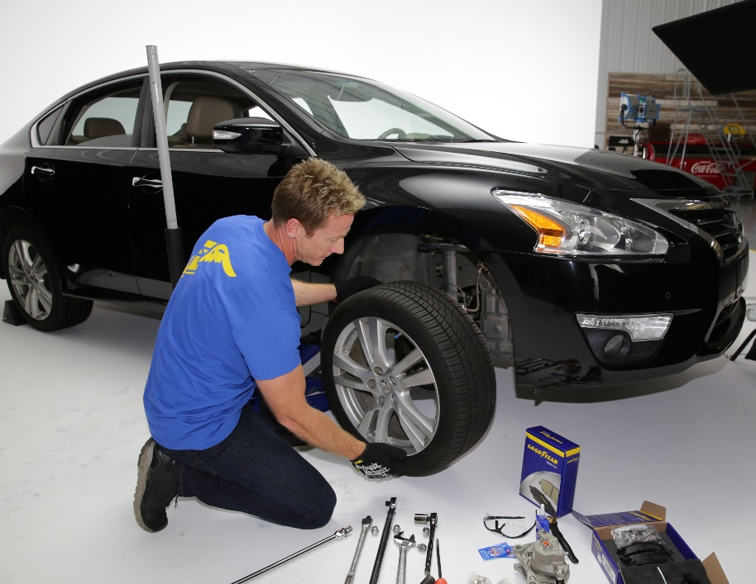
“There is a tremendous opportunity for a trusted brand of braking components in the market today,” said Wally McCarty, Senior Vice President of Business Development for Goodyear Brakes. “While OEM braking systems have improved and advanced, driver assistance systems (ADAS) have reduced extreme brake wear and increased the brakes’ lifespan. There are very few well-known brand names in the brake category, so this makes it difficult for consumers to determine what are premium quality brake system components and fair prices when replacing brakes on their vehicle.”

Goodyear Brakes strives to help ensure that drivers are selecting the safest solution for their vehicle. Premium quality brake bundles, calipers, rotors, brake pads and all the hardware for today’s most popular vehicles, from daily drivers to SUVs as well as light trucks are manufactured by Goodyear Brakes. The product lineup offers the ideal solution for almost every braking need – whether drivers are looking to save money on their vehicle repairs, upgrade their performance or restore their perfect car.
Bruno Massel, Automotive Expert, NHRA Driver, NHRA on Fox Analyst, host of “Garage Squad” and “Truck U”, installs a Goodyear Brakes bundle in the Goodyear Brakes Garage.

“The Goodyear Brakes mission is to provide the most trusted brand of braking components that make your vehicle as safe as possible,” noted Bob Bouwma, Director of Engineering and Advanced Technologies for Goodyear Brakes. “Our team of engineers and scientists work every day to improve the quality, performance and durability of each set of brakes we provide. Using the most advanced technology available in friction science today, the brake bundles are designed to be safe, quiet and long lasting.”

Goodyear Brakes Online Business Model Capitalizes on Consumer Needs, Market Trends

Goodyear Brakes will be sold through www.GoodyearBrakes.com on Amazon and CARid. The portal is designed to give consumers a direct channel to identify their braking system needs using their VIN and license plate information, then order all of the components online. The website also provides expert advice, “How To” videos and proper guidance for brake maintenance and replacement projects.

Aftermarket demand for brake systems and components in North America is forecast to advance 2.6% per annum through 2021 to $4.3 billion, according to the Freedonia Group research. More than 90 percent of the brake pad market is private label products.

Goodyear Brakes are offered through a licensing collaboration with Goodyear, one of the world’s most trusted automotive brands. The brake pads are manufactured in the USA using a proprietary green production process by a company with more than 50 years of experience in friction science. The rotors are made to OEM standards by OEM-approved manufacturers around the world. Calipers are remanufactured in North America, and a majority of that manufacturing process has returned to the United States, bringing important manufacturing jobs back to the American economy.

The Goodyear Brakes Product Line

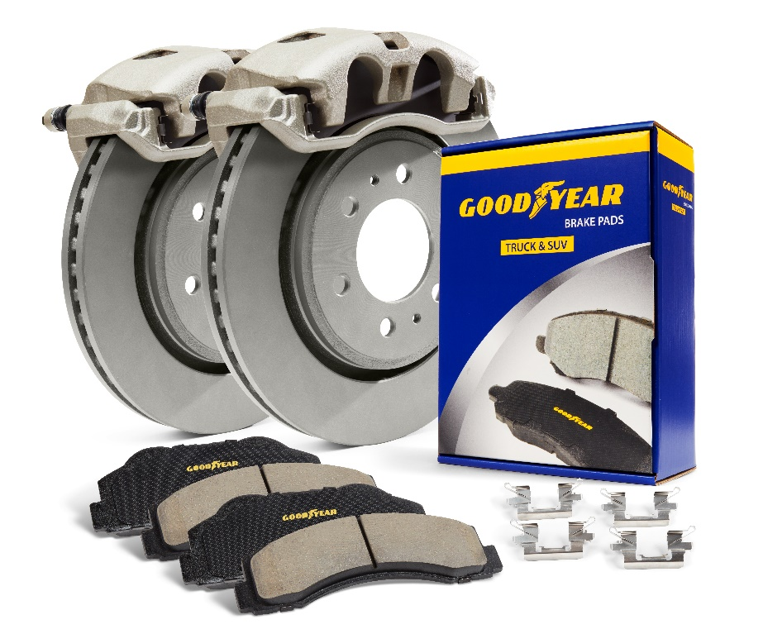
The Goodyear Brakes product line was developed through decades of friction science experience, advanced engineering and thorough laboratory and on-road testing. Testing was performed at the company’s labs in Virginia, and third-party testing was conducted by Link Engineering Company (LINK) in Detroit. Testing included Dynomometer Tests, Independent Laboratory Tests, Environmental Tests and Certification, Analytical Tests, Vehicle Traffic Tests and Performance Vehicle Tests.

Goodyear Brakes braking systems offer superior braking performance and consistent braking through all temperature ranges, as well as excellent corrosion prevention through its proprietary Antiox Max™ coating for maximum rust and corrosion protection. This is a critical protection needed for driving in inclement weather and brine-treated streets.

The full product line includes:
- Goodyear Brakes premium brake pads manufactured in the USA and specifically formulated to provide maximum stopping effectiveness, control and durability
- High-performance Goodyear Brakes rotors that are CNC-machined to build maximum performance, durability and safety into every rotor and feature a proprietary Antiox Max™ coating for maximum rust and corrosion protection, a critical protection needed for driving in inclement weather and brine-treated streets
- High-performance Goodyear Brakes calipers that are built using exacting standards to match original equipment manufacturer (OEM) requirements, feature Antiox Max™ coating and come with the correct brackets and hardware to ensure a perfect installation. Goodyear Brakes calipers are remanufactured in North America, and a majority of that manufacturing process has returned to the United States, bringing important manufacturing jobs back to the American economy

- Goodyear Brakes hardware accompanies every brake bundle to ensure you have all of the high-quality parts to successfully complete your brake installation.

For more information about Goodyear Brakes, visit www.Goodyearbrakes.com, call 877.GET.BRKS (877.438.2757) and follow on Facebook, twitter, LinkedIn, Instagram and YouTube.

About Goodyear Brakes

Goodyear Brakes manufactures premium quality brake bundles, calipers, rotors, brake pads and all the hardware required to successfully install brakes, all backed by a national warranty, decades of production experience and one of the best-known names in automotive excellence. The brake pads are manufactured in the USA using a proprietary green production process by a company with more than 50 years of experience in friction science. The Goodyear Brakes product line is available through www.GoodyearBrakes.com at Amazon, CarID, BuyBrakes.com and autoanything.com.

Goodyear (and Winged Foot Design) and Blimp Design are trademarks of The Goodyear Tire & Rubber Company used under license by FDP Virginia Inc., 1076 Airport Road, Tappahannock, VA 22560, USA. Copyright 2020 The Goodyear Tire & Rubber Company. Goodyear Brakes and FDP Virginia are not responsible for its products when they are subjected to improper applications installation or accident.

About The Goodyear Tire & Rubber Company

Goodyear is one of the world's largest tire companies. It employs about 62,000 people and manufactures its products in 46 facilities in 21 countries around the world. Its two Innovation Centers in Akron, Ohio, and Colmar-Berg, Luxembourg, strive to develop state-of-the-art products and services that set the technology and performance standard for the industry. For more information about Goodyear and its products, go to www.goodyear.com/corporate.

###

