Why Winter Road Brine Can Create Corrosion That Harms Your Brakes’ Performance and Lifespan

How to Prevent Rust and Keep Your Vehicle Ready for Winter Driving

CHARLOTTE -- When you rotated your tires, did you find your brakes and braking components needed replacing well before they’ve reached their expected lifespan because of corrosion? It’s not uncommon. The granular road salt or the now very popular liquid brine solution of calcium chloride or magnesium chloride on the road can be a necessary enemy of your brakes. That same ice-melting aid can wreak havoc on a car’s body, chassis, suspension and brakes through damaging rust and corrosion.
SHOPPING LIST FOR THIS REPAIR:
- Wrenches and sockets to remove and install brake calipers and rotors
- Heavy hammer
- Assortment of wire brushes
- Ceramic or silicone brake parts lubricant
- Brake cleaner aerosol
- Shop towels
- Nitrile rubber gloves and safety glasses
- Replacement brake pads, corrosion-resistant rotors, calipers and hardware from Goodyear Brakes

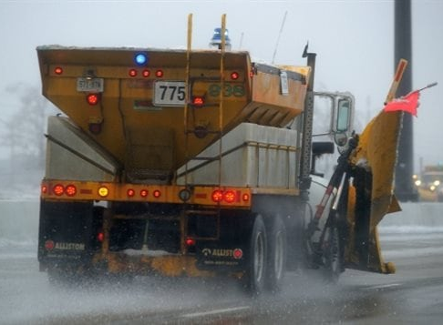
The automotive experts at Goodyear Brakes offer some tips for assessing the health of your vehicle’s braking system and solutions for helping address the prevention of corrosion-related wear. The new line of Goodyear Brakes provides premium quality brake kits, calipers, rotors, brake pads and all the hardware for today’s most popular vehicles, from daily drivers to SUVs and light trucks, all backed by a national warranty, decades of production experience and one of the best-known names in automotive excellence. The Goodyear Brakes product lineup offers the ideal solution for almost every braking need – whether you are looking to save money on your vehicle repairs, upgrade your performance or restore your perfect car.

How Corrosion Can Damage Your Braking System

Corrosion on your braking system can impede brakes’ function, seizing emergency (parking) brake cables and preventing normal, free movement of brake parts such as calipers and pads. As rust builds, it can cause a phenomenon known as “rust jacking,” which can actually separate the pad’s friction material from the backing.

What should a vehicle owner to do, especially if you live in areas that use salt and brine on the roads? There are several solutions to address this, such as installing corrosion-resistant brake components like Goodyear Brakes rotors and calipers protected against rust and corrosion with their proprietary Antiox Max™ protective coating.

How to Help Keep Rust at Bay

- Wash the vehicle as frequently and as soon as possible after a snow or ice storm. Go to an automatic car wash with an undercarriage wash, use the spray wand at a manual car wash or your own pressure washer to direct water in all underbody nooks and crannies to flush away corrosion-causing salt and brine.
- It may seem counter-intuitive, but parking your daily winter driver in a heated garage can actually accelerate brine and salt’s corrosive effects. Their corrosive effects are minimized at freezing temperatures, so parking outside when it’s too cold to wash your car may actually be better for it!
- Lubricate all moving brake parts, such as the caliper pins, with a high-temperature ceramic or silicone brake lubricant (grease.) Apply the same lubricant to the back of each pad where the “ears” of the caliper contact it. Do not use wheel bearing grease, which could liquefy as it heats up and run onto braking surfaces.

How to Deal with Rust That’s Already Present

Rust sometimes causes brake pad friction material to separate from the backing, which means you’ll need new brake pads. Inspect the rotors and calipers for corrosion damage, too. Inspect for rust where the rotor mounts to the hub. This can be removed with wire brushes, either by hand or mounted in a power tool, such as a drill.

How Goodyear Designs Help Prevent Corrosion

Many brake rotors and calipers from the original equipment manufacturer (OEM) – or available as replacements in the aftermarket – are bare metal and are susceptible to corrosion. That means not only is the service life shortened, but if your vehicle features an open wheel design, you’ll have ugly rusty rotors and calipers showing through. You could paint your rotors and calipers, but using hardware-store aerosol paints is time-consuming, can be tricky, and may not last until the next brake job.

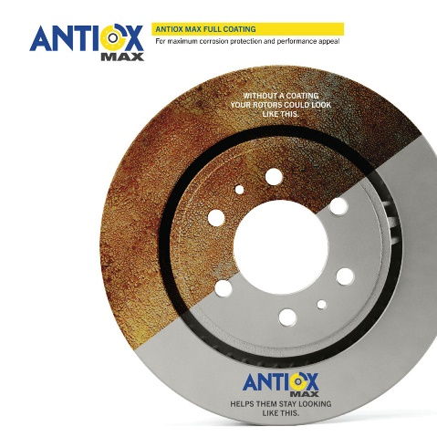
There’s a better solution. Goodyear Brakes rotors and calipers are protected against rust and corrosion with their proprietary Antiox Max™ protective coating, a critical protection needed for driving in inclement weather and brine-treated streets. This means you won’t have to spend your time cleaning off thick oil used in shipping, as some other brands do, or painting the non-braking surfaces. You’ll need only a quick spray of brake cleaner and a clean shop towel to wipe the light oil from the rotor or caliper. It is also worth noting that the entire Goodyear Brakes rotor, including the braking surface, is coated, but it will quickly wear in during the brake pad bedding-in process. That means you’ll be on the road that much sooner, enjoying the stopping power of your new Goodyear Brakes braking system!

For more information about Goodyear Brakes, visit www.Goodyearbrakes.com, call 877.GET.BRKS (877.438.2757) and follow on Facebook, twitter, LinkedIn, Instagram and YouTube.

About Goodyear Brakes

Goodyear Brakes manufactures premium quality brake kits, calipers, rotors, brake pads and all the hardware required to successfully install brakes, all backed by a national warranty, decades of production experience and one of the best-known names in automotive excellence. The brake pads are manufactured in the USA using a proprietary green production process by a company with more than 50 years of experience in friction science. The Goodyear Brakes product line is available through www.GoodyearBrakes.com at Amazon, CarID, BuyBrakes.com, Amazon, Walmart and autoanything.com.

Goodyear (and Winged Foot Design) and Blimp Design are trademarks of The Goodyear Tire & Rubber Company used under license by FDP Virginia Inc., 1076 Airport Road, Tappahannock, VA 22560, USA. Copyright 2021 The Goodyear Tire & Rubber Company.

The Goodyear Tire & Rubber Company. Goodyear Brakes and FDP Virginia are not responsible for its products when they are subjected to improper applications installation or accident.

###

